MINISTRY OF EDUCATION AND TRAINING
VIET NAM INSTITUTE OF INDUSTRIAL CHEMISTRY
------------------------------------

NGUYEN THI HA

RESEARCH CONTINUOUS HYDROGENATION REACTION OF GLUCOSE TO SORBITOL
USING HETEROGENEOUS CATALYST BY EQUIPMENT OF TRICKLE – BED APPLICATION FOR PROCESS PRODUCING OF SORBITOL WITH HIGH PURITY

Field of Study:
Theoretical Chemistry and Physical Chemistry
Code: 62.44.01.19

SUMMARY OF CHEMICAL Ph.D.THESIS

HA NOI – 2015
INTRODUCTION
- Reasons to choose the subject
Sorbitol is a natural polyol sugar. There are many different applications in the industry.
Hydrogenation reaction of glucose to sorbitol has been studied and produced industrially in the world. Traditional hydrogenation procees was mainly conducted in a batch reactor using Ni-Raney catalyst suspensions in the reaction solution. This process also has many disadvantages such as product selectivity is not high, the active phase is "releasing" in the solution.
In recent years, the use of new generation catalyst of Ru/C has overcome the disadvantages of the catalyst Ni-Raney, has attracted the attention of research of scientists the worldwide. Besides, continuous process, using three-phase reactor with fixed layer catalyst (trickle-bed) are also interested in research.
In Vietnam, the demand for sorbitol about several dozen of thousands of tons per year. It must be fully imported. Whereas glucose materials from starch is readily available with a relatively low cost.
Therefore, the study of hydrogenation process of Vietnam glucose to sorbitol on catalyst Ru/C is necessary to provide the scientific basis for the application of produce of sorbitol process in Vietnam.
- Research purposes
Research hydrogenation of pure glucose and raw glucose of Vietnma into sorbitol on modern trickle-bed equipment system, by cotinouos method using heterogeneous catalyst Ru/C.
Find out the window of reaction (the appropriate residence time) for conversion and selectivity optimization.
- Research object
- Materials is Vietnam raw glucose and pure glucose.
- Catalyst 2% Ru/C is prepared in laboratory.
- The reaction hydrogenation glucose was carried out in three-phase systems (trickle-bed) operating under the principle of co-flow from the top to down.
The science and practice meanings
- Reactor system trickle-bed operation has been successful and applications in hydrogenation reactions continuous glucose into sorbitol.
- Catalyst 2% Ru/C-Lab has been prepared with a process stability, high repeatability. Catalytic were characterized and applicated for hydrogenation reaction of glucose into sorbitol. Products sorbitol obtained with high purity for pharmaceutical standards.
- Evaluation of the time life of catalyst and materials effect on the loss of activity catalyst on belong time.
- Regeneration of catalyst methor was found. This is a simple regeneration method. After regeneration porcess activity of catalyst comparable with activity of new catalyst.
With the scientific results obtained from the thesis will be the basis of the application of technology sorbitol production in industrial.
- The new contributions of the thesis
- At the first time in Vietnam, System of trickle-bed reactor was to learn, mining and well run for the hydrogenation reaction glucose to sorbitol.
- Catalysis 2% Ru/C was synthesized with highly active for the hydrogenation reaction of glucose to sorbitol.
- At the first time, raw glucose materials were used forr prearation of sorbitol. Retention time (windows reaction) was chosen to fit in that conversion over 90% and the selectivity over 99%.
- Method simple regeneration of catalyst were studied. After process of regeneration, catalysst rgenerated has activity equivalent new catalyst.
6. Layout of the thesis
The thesis consists of 104 pages divided into sections:
Introduction, Overview, Subjects and Methods, Results and Discussion, Conclusion and References. The thesis consists of 20 tables, 45 pictures and photos and charts, 127 references.

Chapter 1: OVERVIEW
1.1 OVERVIEW FOR SORBITOL

1.1.1 Properties of Physical and chemistry

1.1.2 Capacity and application of sorbitol
Capacity of sorbitol in the world is around 1.2 million tons per year. Sorbitol is used in foods, cosmetics, pharmaceuticals and about 70% for industrial of production vitamin C.
Demand sorbitol in Vietnam about 20- 30 thousand tons/ year from import all.
1.1.3 History of the synthesis of sorbitol
1.1.3.1 Batch Process
1.1.3.2 Continuous process
1.2 Overview of hydrogenation glucose to sorbitol
1.2.1 The mechanism and kinetics of reaction of hydrogenation glucose
Mechanism can be summarized by the interactive process occurs as follows:
H₂ + 2* ↔ 2 (H*)
G + * ↔ G*
G* + 2 (H*) → S +3*
*: the catalytic site; S, G: glucose and sorbitol.
1.2.2 Catalyst for reaction of hydrogenation glucose
1.2.3 The traditional methods of preparation of catalyst Ru/C
Methods most commonly used in laboratory are dry or wet impregnation and ion exchange.
1.2.4 Factors affecting the loss of catalytic activity
Presence of impurities in the raw materials or intermediate products generated during the reaction adsorption on the catalyst surface, covering the active site.
1.2.5 Regenerated catalyst
In industry, the method for regenerating catalytic hydrogenation of glucose to sorbitol hardly be applied.
1.3 OVERVIEW OF TRICKLE-BED REACTOR
1.3.1 The principle of reactor
Reactor of trickle-bed is type of three-phase reactor with catalytic layer fixed that is the most popular applications in the industry. Principle of operation of the reactor is the gas and liquid flows down continuously through the fixed catalyst particles.
1.3.2 Flow regime on the three-phase equipment
- System copper line from the top down
- System copper line from the bottom up
- The system upstream
1.4 RESEARCH ON SORBITOL IN VIETNAM
From 2007 to present, Vietnam Institute of Industrial Chemistry is the first and only place in Vietnam research for sorbitol technology based on scientific works.
Chepter2. EXPERIMENT AND REREARCH METHOR
2.1 EQUIPMENT AND CHEMICALS
2.1.1 Equipment of hydrogenation
The reaction of hydrogenation glucose to sorbitol was conducted on reactor Microactivity - Reference (model: MAPGLM3 - Spain). It is the three-phase equipment, fixed catalyst layer, operating under jet stream.
2.1.2 Chemicals, materials
Chemicals: Norit - Rox activated Carbon France, HCl 35% -38%, distilled water, gas H₂, N₂ of Air Liquide with purity of 99.99%, RuCl3.H₂O of Merk.
Materials: Purity glucose over 98% and raw glucose supply by the Food Industries Research Institute.
2.2. METHODOLOGY
2.2.1 The catalytic characteristic method
- Method of specific surface area and pore distribution (BET);
- Method of transmission electron microscopy (TEM);
- Inductively coupled plasma atomic emission spectroscopy Hydrogen Temperature-programmed desorption;
- The metal dispersion;
2.2.2 The analysis of materials and products
- Energy-dispersive X-ray spectroscopy
- Inductively coupled plasma atomic emission spectroscopy Hydrogen Temperature-programmed desorption;
- High-performance liquid chromatography (HPLC);
- Check the physicochemical properties of the sorbitol Pharmacopoeia standards Vietnam III.
2.2.3 Calculation results
- C (%) = (amount of glucose metabolized/ initial glucose) x 100% = [(initial glucose - glucose not metabolized)/ initial glucose] x 100%
- The selected product P (%) =% P / (initial glucose - glucose not metabolized) x 100%.
- Retention time δ = m/Fg, where m is the mass of activated metal (g), Fg is the flow rate of glucose solution (ml/h).
2.3 EXPERIMENTAL STEPS
2.3.1 Preparation of 2%Ru/C
Catalyst has been prepared by the method of dry impregnating from Norit carbon (the cylindrical particle diameter 0.8mm) and solution of HCl 1N RuCl3.H2O.
2.3.2 Calibration the parameters of the reactor in the laboratory
Calibration process includes: Making baseline pump speed materials; Identify real H₂ flow rate at the output of the reaction; calibration level of the liquid-gas separation; check the co-flow regime from to down.
2.3.3 Research the activity and stability of the catalyst
The evaluation is done with catalyst 2% Ru/C-Lab. Conducting experiments in temperature 100ºC, 80 bar pressure, fluid flow 24 ml/h, material 40% glucose solution of pure type, amount of catalyst in the reaction tube 10 g catalyst (0,18 g Ru). The reaction was performed in 500 hours.
2.3.4 The study on factors affecting the process of hydrogenation glucose to sorbitol
The next experiments were carried out with catalyst 2% Ru/C-Lab, the amount of catalyst in the reaction tube is 10g. Material is pure glucose and raw glucose. The factors studied included: retention time, temperature and pressure.
2.3.5 Research lose catalytic activity and catalyst life time
Monitoring the reaction temperature at 100ºC, 80 bar pressure, flow of 20 ml/h for more than 300 hours (for crude glucose) and 1000 hours (for pure glucose).
2.3.6 Research methods catalyst regeneration
Regenerating the catalyst in the reactor in the presence of hydrogen peroxide. The temperature 30ºC-60ºC, time 2-24 hours, the concentration of hydrogen peroxide 1-5% by weight.
Chapter 3: RESULTS AND DISCUSSION
3.1 Characteristic of catalytic properties
Results of elemental analysis on equipment ICP - AES obtained content of Ru in the catalyst is 1.82% which is, content is approximately the same between the catalyst samples prepared and approximates the content of Ru calculations when Ru impregnated. This proves that the active metal loss during process is negligible, process preparation of catalyst has high stability and repeatability.
Images of transmission electron microscopy (TEM) of the catalysts are shown in figure 3.1.
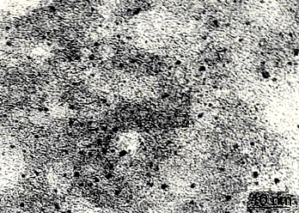 | Figure 3.1: TEM images of the sample catalyst 2% Ru/C

The results in figure 3.1 shows that Ru is dispersed evenly in the support and small size 0,5 nm to 2,5 nm.
Results H₂ desorption characteristics of the catalyst is shown in figure 3.2.
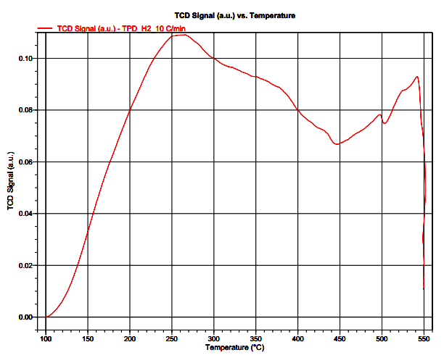
Figure 3.2: Diagram TPD of 2%Ru/C-Lab
In figure 3.2, appearance three peaks desorption H2 at the temperatures respectively 259,8ºC; 401,6ºC and 535,7ºC.
According to result obtained, the H₂ desorption occurs mainly in temperature 259,8ºC. At the peaks at higher temperatures (401,6ºC and 535,7ºC), the concentration of H₂ desorption is very low. Type H₂ released at low temperature (259,8ºC) is the chemical adsorption of H₂ with Ru metal particles. The H₂ released at high temperature (401,6ºC and 535,7ºC) may be the type H₂ "spillover" adsorbed on the support. With TPD results obtained clearly H₂ adsorbed mainly on the Ru metal particles. Thus catalyst 2%Ru/C-Lab suitable for reactions hydrogenation glucose carried out at temperature of about 100ºC.
Specific surface area and pore properties of activated carbon and catalyst 2% Ru/C-Lab is characterized by methor of adsorption and desorption isotherm N₂. The results obtained in the figure 3.3a, 3.3b, 3.4a, 3.4b.

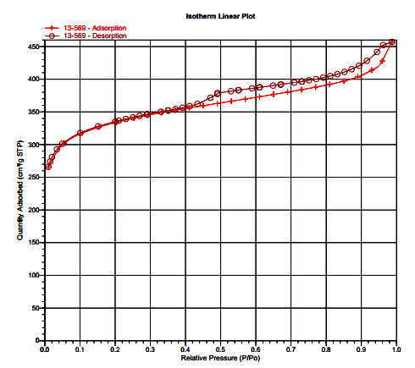 | 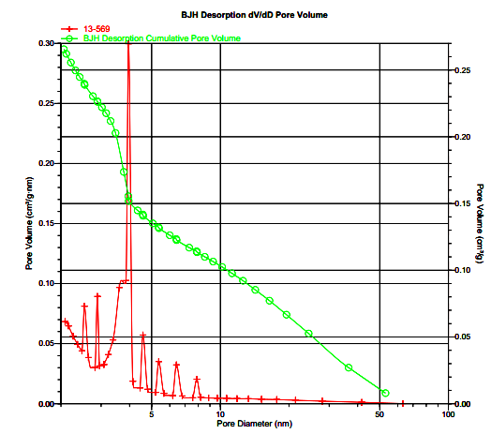
Figure 3.3a: Digram adsorption and desorption of N₂ isotherm of activity cabon | Figure 3.3b: Distribution pore of activity cabon

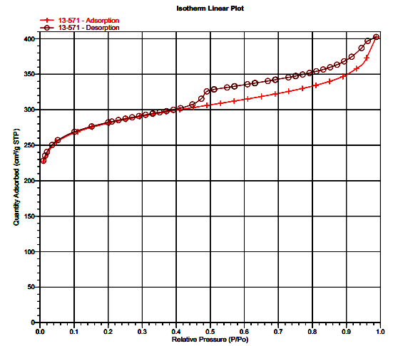  Figure 4.3a: Digram adsorption and desorption of N₂ isotherm of | 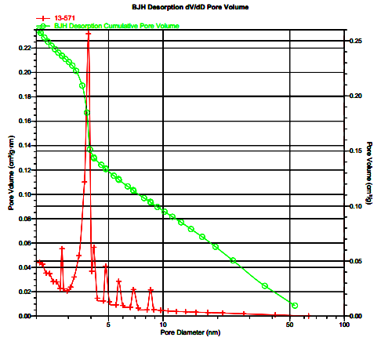  Figure 4.3b: Distribution pore of 2%Ru/C- Lab catalyst
The results in figure 3.3a and 3.4a shows that the support has an structure of average pore. The similarity of the shape of the path delay and pore size distribution between 3.4a with 3.3a image shows that impregnation process of Ru on activated carbon does not affect the structure the porous of support.
The structural parameters of the support and catalyst are summarized in table 3.3.
Table 3.3: The chemical and physical properties of the support and catalyst
No | Name sample | S_{BET}(m²/g) | Vpore, cm³/g
1 | C_{Norit} | 1089 | 0,7
2 | 2% Ru/C-PTN | 920,38 | 0,622
The result obtained shows that the active Ru particles dispersed on the outer surface and the inner surface of the capillary. Which leads to reduction of specific surface area and average pore volume of the catalyst. However, this reduction level is not significant.
Catalyst is also determined the dispersion of the active metal by the method characterized by CO pulse adsorption. The results CO pulse adsorption of two sample catalyst in two different experimental notation 2% Ru/C-Lab-01 and 2% Ru/C-Lab-02 is presented in figure 3.5 and 3.6.

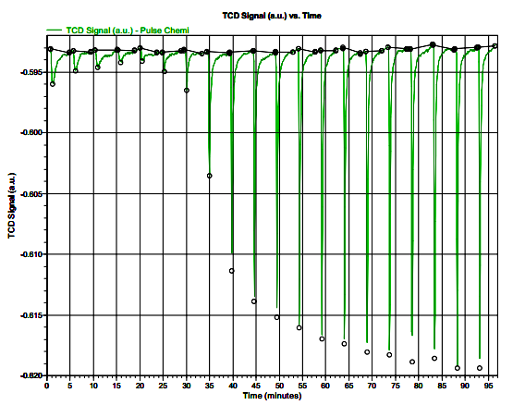 | 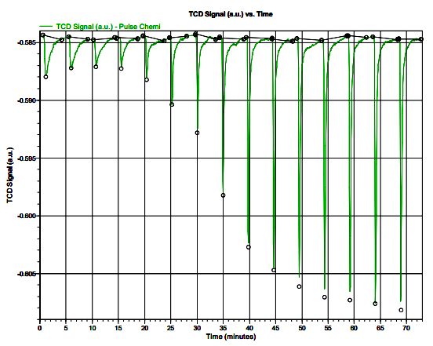
Figure 3.6: Diagram CO pulse adsorption of catalyst  2%Ru/C-Lab-01 | Figure 3.7: Diagram CO pulse adsorption of catalyst 2%Ru/C-Lab-02
Results of the average dispersion of two catalytic sample is calculated as 55.0394%. This means that the activity Ru accounted 55.0394% compared to the Ru atoms are brought up to the support.
3.2 CALIBRATION PARAMETERS OF REACTOR AND TEST FLOW REGIME
3.2.1 Establish baseline speed pump materials
The dependence of the real fluid flow rate according to the on-screen liquid flow rate is displayed in figure 3.7.
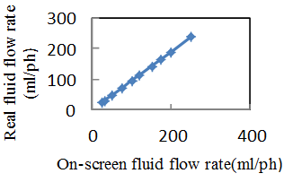
Figure 3.7:
The dependence of the real fluid flow rate on the on-screen liquid flow rate
From the experimental points obtained line represents the linear dependence of the real fluid flow rate according to the on- screen fluid flow rate. This shows that the reactor is stable and high degree of accuracy. In figure 3.7, the value Freal is calculated according to the expression: Freal = 0.95 * Fon-screen. With this expression, easy to adjust the liquid flow necessary.
3.2.2 Identify reality H2 gas
- Initial H₂ flow rate while increase the pressure to reaction pressure: if Fn = Fmax = 1250 ml/min then Foutlet = 1387 ml/min.
- H₂ flow rate during the reaction:
if Fn = 300 ml/min then Foutlet = 333 ml / min.
3.2.3 Calibration and monitoring the stability of the level sensor of liquid products
3.2.3.1 Calibration
The dependence of the frequency of level sensor on the volume of the solution in the separator is shown in figure 3.8.

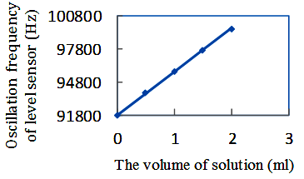
Figure 3.8: The dependence of the frequency of level sensor on the volume of the solution
Results obtained shows that the value of oscillation frequency at the levels (F_{0,5ml}, F_{1ml}, F_{2ml}) changes linearly with the volume of fluid inside separator. This demonstrates that the sensor is functioning properly. And so the results extrapolated to calculate MAX.LEVEL (F_{10ml}) is completely reliable.
3.2.3.2 Observation time required to stabilize the level of liquid products
During the reaction, liquid level is set equal 2. Time required to stabilize the level of liquid products is shown in figure 3.9.
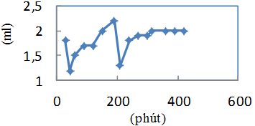
Figure 3.9: The level of liquid gas separation
The results in figure 3.9 shows that level of liquid gas is stable after 6h. From this point, the product can be extracted out for analysis periodically.
3.2. TEST MODE CO-FLOW IN TRICKLE-BED REACTOR
Chart the dependence of convertion on retention time is shown in figure 3.10.
.
Figure 3.10: The dependence of convertion on retention time

Results in figure 3.10 shows, the convertion increases linearly with retention time. Thus, it can be concluded that the catalyst 2% Ru/C coincidence co- flow regime from top to down of the reactor and the activity of catalyst is not affected by diffusion factors.
3.3 ANALYSIS OF MATERIALS
The analytical results materials by EDX methor is given in figure 3.11 and 3.12.
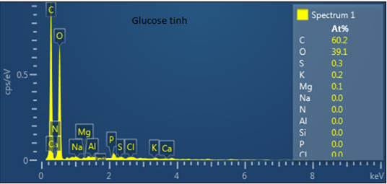 | 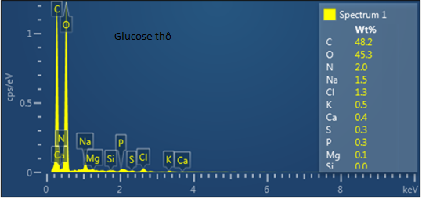

Figure 3.11: EDX spectra of pure glucose
Figure 3.12: EDX spectra of
crude glucose

According to the results obtained from Figure 3.11 and 3.12, pure glucose material is almost no impurities. For raw materials glucose was determined the presence of elements N, Cl, Na, Ca, K, P. Meanwhile, pure glucose material is not found these the elements. The impurities is presence amount significant in raw glucose material include: N (2%), Cl (1.3%) and Na (1.5%).
3.4. EVALUATION ACTIVITY AND STABILITY OF CATALYST
The activity and stability of the catalyst 2% Ru/C-Lab for hydrogenation reactions glucose is given in table 3.8.
Table 3.8: The revolution activity of catalyst
(100ºC, 80 bar, 24 ml/h, pure glucose 40%, catalyst 10g)
No | t (h) | F_{g} (ml/h) | δ.10⁴  (g_{Ru}.h/ml) | Convertion  (%) | Selectivity
 |  |  |  |  | Sorbitol  (%) | Mannitol (%)
1 | 14 | 24 | 75 | 96,6 | 98,5 | 1,5
2 | 22 | 24 | 75 | 99,7 | 98,9 | 1,1
3 | 25 | 24 | 75 | 100 | 99,1 | 0,9
4 | 63 | 24 | 75 | 100 | 99,0 | 1,0
5 | 71 | 24 | 75 | 100 | 99,1 | 0,9
6 | 87 | 24 | 75 | 100 | 99,2 | 0,8
7 | 167 | 24 | 75 | 100 | 99,1 | 0,9
8 | 184 | 24 | 75 | 100 | 99,3 | 0,7
9 | 206 | 24 | 75 | 100 | 99,1 | 0,9
10 | 230 | 24 | 75 | 100 | 99,2 | 0,8
11 | 255 | 24 | 75 | 100 | 99,2 | 0,8
12 | 327 | 24 | 75 | 100 | 99,3 | 0,7
13 | 500 | 24 | 75 | 100 | 99,1 | 0,9

From the results in table 3.8 show that, after the first 25 hours of operation, reactor has been stable and the convertion of glucose reaches 100%, the selectivity was over 99%. Conversion and selectivity are not almost changed during the 500-hour continuous reaction. Thus, catalyst 2% Ru/C-Lab has highly activity and stability for hidrogenation reaction of glucose to sorbitol.
3.5. INFLUENCE OF PARAMETERS
3.5.1. Temperature dependency
The influence of temperature on the glucose conversion and selectivity are shown in figure 3.13 and 3.14.

Figure 3.13: Effect of conversion and selectivity on the reaction temperature (pure glucose 40%, 20 ml/h, 80 bar, 10g catalyst)

Figure 3.14: Effect of conversion and selectivity on the reaction temperature (raw glucose40%, 20 ml/h, 80 bar, 10g catalyst)

Figure 3.13 and 3.14 shows that at high temperatures (above 100ºC), different materials influence significantly on the activity of the catalyst. With pure materials, the conversion is not affected by temperatures over 100ºC, but with the raw material conversion decreased when increasing temperature above 100ºC. The sorbitol selectivity is improved at low temperature for both materials. At 100ºC, sorbitol selectivity is over 99%, at 130ºC, the sorbitol selectivity is lower. This is caused by chemical reactions creating mannitol and fructose at higher temperatures. The results in table 3.8 was seen the presence of fructose at 120ºC and 130ºC temperature for both materials.
Thus, for both materials, optimal temperature for conducting the reaction is 100ºC.
3.5.2 Effect of pressure
The effect of pressure on sorbtiol selectivity and glucose conversion is shown in figure 3.15, 3.16.
Figure 3.15: The effect of pressure on glucose coversion (20 ml/h, 100ºC, glucose 40%, 10g catalyst)

Figure 3.16: The effect of pressure on sorbtiol selectivity
(20 ml/h, 100ºC, glucose 40%, 10g catalyst)
From the results obtained in figure 3.15 shows that, when the pressure increases in the range of 10-50 bar conversion increased rapidly. This proves that the low-pressure range, the reaction is limited by the pressure of H₂, so the reaction rate depends on the amount of dissolved hydrogen on the exposure surface of the liquid and gas. However, when the pressure increases in the range of 50-70 bar, the conversion decreased, the pressure range from 70 bar - 90 bar conversion less dependent on pressure.
Figure 3.16 shows that the pressure increased from 10 bar to 70 bar, selectivity increased from 91.7 to 99% (for pure glucose) and from 91.0% to 98.9% (for raw glucose). The pressure increased from 70 bar to 90 bar selectivity on both materials changes negligible and approximately 99%. So the pressure suitable for hydrogenation reactions of glucose to sorbitol is 80 bar.
3.5.3. Effect of liquid flow
Figure 3.17 and 3.18 shows the dependence of the conversion (left axis) and selectivity (right axis) on the retention time. For pure glucose material, the optimal retention time from 75 gRu.h / ml to 90 gRu.h / ml.
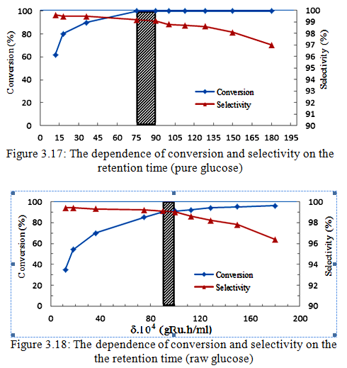
In this area, the glucose conversion is 100% and the sorbitol selectivity is over 99%. For glucose raw materials, the best retention time range obtained conversion is over 90% and the selectivity is over 99% from 90 gRu.h/ml to 100 gRu.h/ml. Optimal retention reaction zone (the cross on figure) is called the window of the reaction. Easy to see that the reactive window of raw materials have shifted compared to pure materials toward higher retention time and reactive windows of raw material also narrower of pure glucose material.
3.6 RESEARC OF ACTIVITY AND LIFE TIME OF CATALYST
3.6.1 Effect of materials concentration on the loss of catalytic activity
Results dependence of the glucose conversion and sorbitol selectivity on reaction time at different glucose concentrations are given in table 3.12 and 3.13.
Table 3.12: Effect of pure glucose concentration on the loss of catalytic activity (100ºC, 80 bar, 20 ml/h, 10g catalysts )
Time (h) | Glucose 40% |  | Glucose 50%
Time (h) | Conversion (%) | Selectivity  (%) | Conversion (%) | Selectivity  (%)
200 | 100 | 99,0 | 100 | 99,1
370 | 100 | 99,1 | 100 | 99,2
600 | 100 | 99,3 | 100 | 99,3
760 | 99,5 | 99,3 | 99,4 | 99,2
900 | 99,3 | 99,2 | 99,3 | 99,2
950 | 99,1 | 99,3 | 99,1 | 99,3
1000 | 99,0 | 99,2 | 99,1 | 99,3

Table 3.13: Effect of raw glucose concentration on the loss of catalytic activity (100ºC, 80 bar, 20 ml/h, 10g catalysts )
Time (h) | Glucose thô 40% |  | Glucose thô 50%
Time (h) | Conversion (%) | Selectivity  (%) | Conversion (%) | Selectivity  (%)
50 | 90,5 | 99,1 | 91,0 | 99,1
75 | 90,4 | 99,2 | 89,8 | 99,0
100 | 88,0 | 99,1 | 85,2 | 99,3
150 | 82,3 | 99,2 | 77,9 | 99,3
175 | 80,1 | 99,3 | 71,7 | 99,1
200 | 78,0 | 99,1 | 67,1 | 99,2
250 | 75,2 | 99,1 | 63,0 | 99,3
300 | 71,4 | 99,2 | 56,3 | 99,2
The results in table 3.12 and 3.13 shows that, for both materials, the concentration of glucose do not effect on the selectivity over time and selectivity is always over 99%. However, for the material is pure glucose, the glucose concentration changes from 40% to 50% almost no effect on the loss of catalytic activity over time. Meanwhile for raw materials, loss of catalytic activity is slower at the concentration of glucose 40%. In this case, conversion of reaction decreased from 90.5 to 71.4 in the first 300 hours. At the concentration of raw glucose higher (50%), the decreasing of catalyst occurs more rapidly. In this case, conversion decreased from 91% to 56.3% during the first 300 hours of reaction. Thus, when the increasing concentration of crude glucose solution lead to impurities in the material increases and increases negatively impact the catalytic activity thus the decreasing of catalytic activity happen faster. So the concentration glucose suitable for the reaction is 40%.
3.6.2 Research the life of the catalyst
The change in selectivity and conversion with time are shown in figure 3.19 and 3.20.
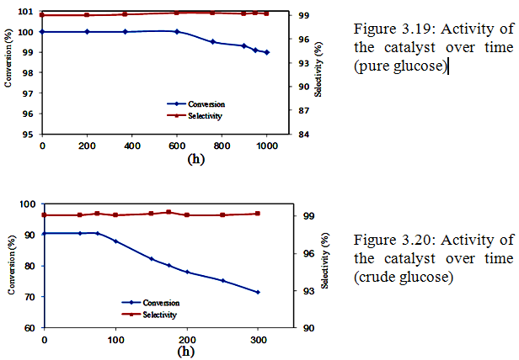
The results obtained shows that, for both materials selectivity hardly changed over time and always over 99%. Meanwhile, the coversion decreases over reaction time. For pure glucose, after 1000 hours of reaction, only glucose conversion decreased from 100% to 99%. For crude glucose, only after 300 hours of reaction conversion reduced from 90.5 to 71.4%.
This is explained by EDX spectrum of catalyst reduced activity compare with EDX spectrum of fresh catalysts (figure 3.21 and 3.22).
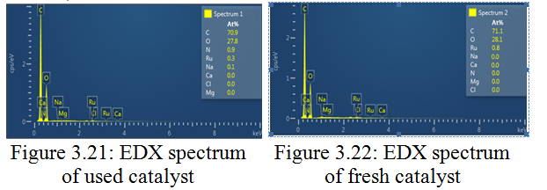
The results obtained showed that, the catalysts after reduction reaction activity in a long time with were present 0.9% N and 0.1% Na. Thus the composition of impurities in crude materials infected in catalyst.
3.7. RESEARCH REGENERATION OF CATALYST
After glucose conversion decreased from 90.5% to 71.4%, the catalyst Ru / C was regenerated with a solution of hydrogen peroxide.
The influence of the hydrogen peroxide concentration on regeneration process is shown in table 3.14.
Table 3.14: The influence of the hydrogen peroxide concentration
The results obtained in table 14.3 shows the hydrogen peroxide concentration suitable for catalyst regeneration is 2% to 4% .
No | H₂O₂  (%) | Conversion  (%) | Selectivity  (%)
1 | 1 | 80 | 99
2 | 2 | 89 | 99
3 | 3 | 89 | 99
4 | 5 | 89 | 99
Influence of temperature on regeneration process are given in table 3.15.
Table 3.15: Influence of temperature
The results obtained in table 3.15, regeneration temperature is suitable at 40ºC to 60ºC.
No | Temperature (ºC) | Conversion  (%) | Selectivity  (%)
1 | 30 | 77 | 99
2 | 40 | 88 | 99
3 | 60 | 88 | 99
Results effect of time on regeneration process are given in table 3.16.
Table 3.16: Effect of time
No | Time  (h) | Conversion  (%) | Selectivity  (%)
1 | 2 | 73 | 99
2 | 3 | 78 | 99
3 | 4 | 87 | 99
4 | 7 | 87 | 99
5 | 24 | 87 | 99
The results obtained in table 3:16 appropriate regeneration time is 4-5 hours.
Catalysis Ru/C after regeneration reaction was tested in appropriate conditions such as running with the new catalyst (glucose 40%, 80 bar, 100ºC, 20 ml/h, 10 g catalyst) to test the effectiveness and stability of the regeneration catalyst.

The results shows, catalyst can reuse many times by this regeneration methor.

3.8 ANALYSIS OF SORBITOL
3.8.1Analysis of sorbitol by HPLC
HPLC chromatogram of sorbitol samples are shown in figure 3.24.
Results of HPLC analysis obtained the purity of sorbitol 99.2% and mannitol is 0.8%.

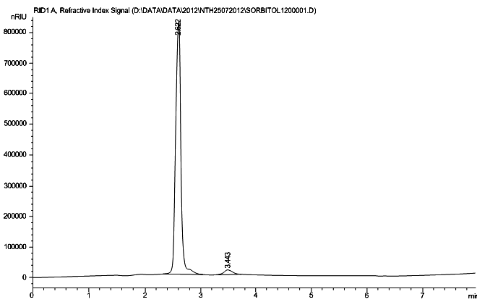 | Hình 3.24: HPLC chromatogram of sorbitol
3.8.2 Evaluation of physico-chemical indicators of the sorbitol
Results of the analysis of physico-chemical indicators by the Vietnam III pharmacopoeia combined và the results of analysis of Ru content by ICP showed that sorbitol have chemical and physical properties achieve Vietnam III Pharmacopoeia standards. It did not detect the presence of Ru in the sorbitol.
CONCLUSION

1. Parameters of equipment were calibrated before operation for the first time in Vietnam. 2%Ru/C-PTN catalyst was approved concordance with the co- stream flow regime from top to down.
2. Mainly impurities component in the cude glucose feed consists of compounds of nitrogen, sodium and chlorine.
3. Conditions for the reaction: temperature 100ºC, pressure 80 bar, retention time 75.10-4-90.10-4 gRu.h/ml (for pure glucose) and 90.10-4-100.10- 4 gRu.h/ml (for crude glucose).
4. The factors effecting on the catalytic activity were studied, include: glucose concentration and reaction temperature. For pure glucose solution, concentration does not effect on the catalytic activity. For rude glucose solution, in high glucose concentrations, loss of catalytic activity occurs faster. For temperature, the loss of catalytic activity occurs faster when the temperature rises above 100ºC.
5. The life time of the catalyst was studyed. For both materials, the selectivity of sorbtol almost constant in during reaction and always obtain over 99%. After 1000 hours of reactions, in case pure glucose, conversion decreased from 100% down to 99%. However, conversion of crude glucose after 300 hours decreased from 90.5 down to 71.4%.
6. The uesed catalyst was measure by EDX and found that the impurity composition of crude glucose was present in the catalyst.
7. The method of catalyst regeneration by hydrogen peroxide has been optimized in the following conditions: Flow of hydrogen peroxide 10ml/min, the concentration of hydrogen peroxide: 2-4%, regeneration temperature: 40ºC, the regeneration time: 4 hours. Catalysis after regeneration is highly active and stable approximately fresh catalysis.
8. Sorbitol products were evaluated by HPLC for purity reached 99.2%. The chemical and physical of sorbitol achieve standards of Vietnam III Pharmacopoeia.

